
SHREDR AI: Design and Implementation of an ai assisted malware triage system
IT8532 – Advanced Artificial Intelligence and Machine Learning – Assessment 2


emily vartha - nmit
2026

Contents
1. Task Definition and Architecture 5
1.1 Task Definition 5
1.2 Division of AI Responsibilities 5
1.3 System Architecture 6
1.4 Built, EduStack-Provided and Absent Components 7
2. Data Preparation and Feature Engineering 7
2.1 Problem Framing 7
2.2 Dataset 7
2.3 Data Preparation 8
2.4 Train, Validation and Test Split 9
2.5 Leakage Prevention 9
3. Model Selection and Training 10
3.1 Model Selection 10
3.2 Alternative Approach 10
3.3 Training 11
3.4 Trivial Baseline 11
4. Model Evaluation 12
4.1 Validation Performance 12
4.2 Operational Threshold Selection 12
4.3 Final Test Results 14
4.4 SHAP Analysis 15
4.5 Disparate Performance Audit 16
5. Deployment of the Prediction Service 16
5.1 HTTP Prediction Service 16
5.2 Request Contract 17
5.3 Response Contract 17
5.4 Malformed Input 18
6. Fine-tuning with Unsloth 19
6.1 Fine-tuning Purpose 19
6.2 Instruction Dataset 19
6.3 Dataset Cleaning and Split 20
6.4 Dataset Provenance and Licensing 21
6.5 Base Model and Unsloth: 22
6.6 LoRA Configuration 23
6.7 Training Results and Loss 24
6.8 Training and Inference Format 25
7. Export and Deployment 25
7.1 Exporting the Fine-Tuned Model 25
7.2 Quantisation Selection 26
7.3 Chat Template Consistency 26
7.4 Deployment to CT200 27
7.5 Registering the Router Backends 28
7.6 Base Model Verification 29
7.7 Final Deployment Architecture: 29
7.8 Deployment Outcome 30
8. Agent Orchestration 30
8.1 OpenClaw’s Role in SHREDR AI 30
8.2 OpenClaw Skill 31
8.3 Goal and Stopping Condition 31
8.4 Prediction Endpoint as a Tool 32
8.5 Using the Prediction to Decide 32
8.6 Language-Model Report Generation 33
8.7 Acting on a Real Gitea Artefact 33
8.8 Independent Verification 33
8.9 Restricted OpenClaw Configuration 34
8.10 Limitations of Autonomous Tool Selection 35
8.11 Orchestration Outcome 36
9. Guardrails and Failure Handling 36
9.1 Purpose of the Guardrails 36
9.2 Failure Mode 1 – Invalid or Incomplete Prediction Input 36
9.3 Failure Mode 2 – Prediction Service Unavailable 37
9.4 Failure Mode 3 – Prediction Close to the Decision Threshold 38
9.5 Additional Input Validation 39
9.6 Human Approved Boundary 39
9.7 Guardrail Outcome 39
10. System Evaluation 40
10.1 Base Model vs Fine-Tuned Model 40
10.2 Fine-tuned Model Failure 41
10.3 Complete System Evaluation 41
10.4 Failure Attribution 43
11. Critical Analysis and Report 43
11.1 Business Implications 43
11.2 Technical Implications 43
11.3 Social Implications 44
11.4 Accountability 44
11.5 Requirements before Production Use 44
11.6 Submission Documentation 45
11.7 Conclusion 45
Generative AI Use Statement 45
References 45

Figure 1 SHREDR AI’s System Architecture Diagram 6
Figure 2 Code Snippet Output of Dataset and Class Distribution 8
Figure 4 Code Snippet (Jupyter Lab) Output of Split Distribution 9
Figure 3 Code Snippet (Jupyter Lab) Output of the Arranged 70/15/15 Split 9
Figure 5 Code Snippet (Jupyter Lab) Output of Constant Training Features 10
Figure 6 Code Snippet (Jupyter Lab) Output of Removed Training/Validation/Test Features 10
Figure 7 Code Snippet Output of the Baseline and XGBoost Comparison 11
Figure 8 Code Snippet (Jupyter Lab) Output of XGBoost Validation Results 12
Figure 9 Code Snippet Output of a Detailed Outline of the rate of False Positives and False Negatives 13
Figure 10 Code Snippet (Jupyter Lab) Output of the Final Test Results using Threshold 0.10 14
Figure 11 SHAP Diagram (from Code Snippet Output (Jupyter Lab)) for Further Analysis 15
Figure 12 Performance Audit based on Different Executable Size Groups 16
Figure 13 Command Prompt Snippet Loading the Status of CT200 17
Figure 14 Command Prompt Snippet of Success Response 17
Figure 15 Command Prompt Snippet of Output showing Error 400 (Deliberate Test) 18
Figure 16 Command Prompt Result showing Deliberate Malformed Input Result for Validation 18
Figure 17 Instruction Dataset Formatting Example for SHREDR AI’s Internal Components 20
Figure 18 Code Snippet (Google Colab) Output of Dataset Split 21
Figure 19 Google Colab Environment Setup Code and Output 22
Figure 21 Colab Main LoRA Configuration 23
Figure 20 Colab Adapters 23
Figure 23 In-depth Code Snippet (Jupyter Lab) Output for History Loss and Evaluation Loss 24
Figure 22 Code Snippet (Jupyter Lab) Output for History Loss and Evaluation Loss – Second Test 24
Figure 24 Diagram depicting Fine-Tuning Loss 24
Figure 25 Command Prompt Output defining GGUF Files – Based and Tuned Versions 25
Figure 26 Code Snippet (Google Colab) Output of Chat Template Example Result 27
Figure 27 Command Prompt Output of Deployment Verification for CT200 27
Figure 28 Command Prompt Response for Router Configuration 28
Figure 29 Command Prompt Output For Edustack Configuration Results 28
Figure 30 Command Prompt Output of OpenClaw Skill Validation 30
Figure 31 Command Prompt Output for Independent Verification for OpenClaw 33
Figure 32 Command Prompt Output for Restricted OpenClaw Configuration 34
Figure 33 Command Prompt Output for Failure Mode 1 – Invalid/Incomplete Prediction Input 36
Figure 34 Command Prompt Output for Failure Mode 3 – Prediction Close to Decision Threshold 37
Figure 35 Code Snippet Output of Base and Fine-Tuned Model Evaluation on the 22 held-out test examples 39
Figure 36 Code-snippet Output of Boundary Case Failure Identified during Fine-tuned Model Evaluation 40
Figure 37 SHREDR AI Incident Report in Gitea 41

Table 1 Categories and Components of the Build 7
Table 2 SHREDR AI’s Dataset Sources 7
Table 3 Record numbers for each split 9
Table 4 XGBoost Classifier Configurations 11
Table 5 Baseline vs XGBoost Accuracy Values Comparison 11
Table 6 Validation Performance Table for XGBoost 12
Table 7 Table of Operational Costs at Different Thresholds 13
Table 8 Final Test Results for Evaluation 14
Table 9 Endpoints used for SHREDR AI 16
Table 10 Dataset Division Table 20
Table 11 Deployment Configuration for SHREDR AI 29
Table 12 SHREDR AI Workflow Outcome Options 31
Table 13 Probability and Threshold Deterministic Results 32
Table 14 Components in SHREDR AI and their Responsibilities 35
Table 15 Base Model vs Fine Tuned Model Evaluation Criterion Comparison Table 39
Table 16 Final Results Table of Each Test, Expected Behaviour, Component and their Pass/Fail Verdict 41

Task Definition and Architecture

1.1 Task Definition
SHREDR AI is a malware triage and incident reporting subsystem. It is designed to assist an IT or security analyst when assessing executable files that could be potentially malicious. The system accepts a set of pre-extracted static features from an executable and determines whether the file is likely to be benign or malicious. It then converts the technical prediction into a short incident report and records that result as an ‘issue’ in Gitea.
The intended user is an IT administrator or security analyst who needs to prioritise suspicious files for investigation. SHREDR AI is designed as a decision-support system rather than an autonomous antivirus product. It does not execute, modify, delete, upload or quarantine the file being assessed.
A wrong prediction could have different consequences which depend on the type of error. A false negative, where malware is classified as benign, is the more serious error as malicious software could then be trusted or receive insufficient investigation. A false positive could cause a legitimate file to be unnecessarily escalated for manual review, which creates extra analyst workload but less direct security risk. For this reason, false negatives are considered more costly during model evaluation.
Unsafe language-model output can also present a risk. For example, the language model can exaggerate the certainty of the classifier or invent evidence that was not given. The language component is therefore told to only use supplied classifier evidence, while deterministic controls can require human review instead of allowing the generated report to determine a security action.

1.2 Division of AI Responsibilities
The system separates structured prediction from language generation.
The structured prediction is performed by an XGBoost classifier. It receives 242 numeric malware features and outputs a benign/malware classification and malware probability. XGBoost is appropriate for this component since the problem is tabular classification rather than natural-language reasoning (Chen & Guestrin, 2016). It also provides a numerical probability that can be compared against a fixed decision threshold.
The language components uses a fine-tuned Qwen2.5-1.5B-Instruct model (Qwen Team, 2024). The model does not decide whether the executable is malware. Instead, it receives the classifier result and converts that evidence into an analyst-readable report containing a risk assessment, evidence interpretation and recommended action.
Having this separation means that there is prevention for the language model from replacing the conventional classifier for numerical prediction. The classifier owns the security classification, while the language model owns presentation and interpretation of the supplied result.

1.3 System Architecture
The completed system consists of three main deployed components:
CT200 – Inference: Hosts the XGBoost prediction API, fine-tuned Qwen model and EduStack model-routing infrastructure.
CT201 – OpenClaw: Hosts the ‘shredr-predict’ skill and deterministic triage.py workflow used to coordinate prediction, report generation, guardrails and repository interaction.
CT202 – Gitea: Hosts the private ‘shredr-incidents’ repository used to create an auditable incident record.
OpenClaw is given restricted tool access, and the workflow has an explicit stopping condition: stop after one verified Gitea incident issue is created or stop safely with a manual-review result if a required stage fails.
Figure 1
SHREDR AI’s System Architecture Diagram
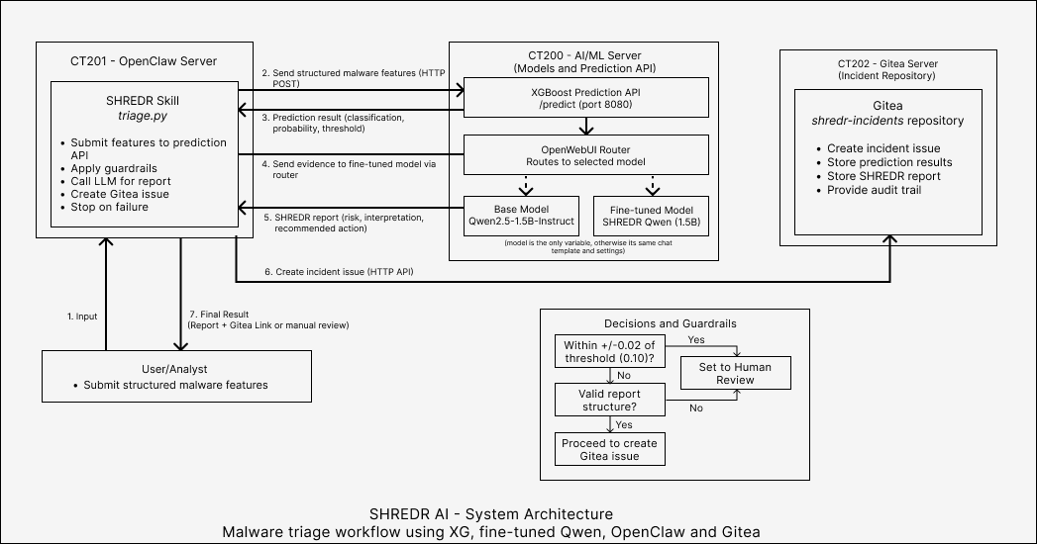
Note. This depicts the structure of the architecture built for SHREDR AI. It details each component and how it connects with the others.

1.4 Built, EduStack-Provided and Absent Components
Table 1
Categories and Components of the Build
Category | Components
Built for SHREDR AI | XGBoost malware classifier, FastAPI prediction service, instruction dataset, LoRA fine-tuned Qwen2.5-1.5B model, ‘shredr-predict’ OpenClaw skill, ‘triage.py’ workflow, deterministic guardrails and Gitea incident integration.
Provided by EduStack | Proxmox/container environment, CT200 inference infrastructure, llama.cpp model serving, MultiShim/router infrastructure, OpenClaw environment and Gitea environment.
Absent for this implementation | Live malware execution or sandboxing, automatic quarantine/deletion, antivirus replacement, dynamic execution analysis, autonomous remediation and production endpoint integration.
Note. This table demonstrates what categories and components are compiled for this project, including what is absent for this implementation and what could be produced in the future.
SHREDR AI produces triage information and an auditable incident report, while consequential actions remain the responsibility of a human analyst.

Data Preparation and Feature Engineering

2.1 Problem Framing
The structured machine-learning problem was framed as binary classification of Windows executable files:
- 0 – Benign
- 1 – Malware
The model uses previously extracted static and behavioural characteristics rather than executing the file. This keeps the prediction component focused on structured numerical data and avoids the safety risks associated with executing malware as part of the project.

2.2 Dataset
The dataset combined three collections (UCI Machine Learning Repository, 2019):
Table 2
SHREDR AI’s Dataset Sources
Source | Records
Benign dataset | 595
VxHeaven | 2,698
VirusTotal | 2,955
Total | 6,248
Note. This outlines how many records are in each source of the dataset used in SHREDR AI. Both VxHeaven and VirusTotal contained malware records.

The combined dataset was rather imbalanced, containing 5,653 malware records (90.48%) and 595 benign records (9.52%). This imbalanced was retained rather than artificially balancing the dataset, but it was considered during evaluation by using metrics such as balanced accuracy, precision, recall and F1 rather than relying on accuracy alone.
Figure 2
Code Snippet Output of Dataset and Class Distribution
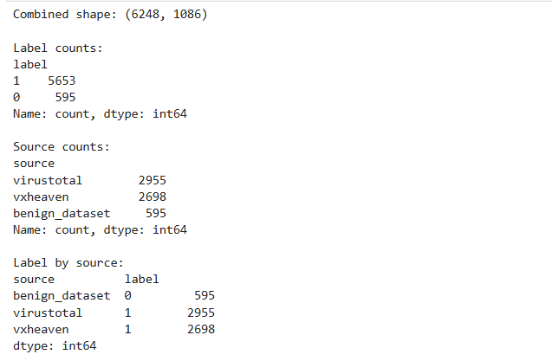
Note. This code snippet outlines the fact that there are 5,653 malware (1) files and only 595 benign (0) files. Additionally, it provides specific details on what sources are combined to create the total number of records and its 0 or 1 label. Found in 01_xgboost_training.ipynb (Jupyter Lab)

2.3 Data Preparation
The label, source and SHA256 columns were excluded from the model’s feature matrix. Label is the prediction target, while source could directly reveal which collection a record came from and therefore have leakage.
The SHA256 field was unsuitable as a predictive feature. Inspection found only one unique SHA256 value across the dataset, meaning it contained no useful discriminatory information. This initially produced 1,083 candidate numerical features.
After the train/validation/test split, constant features were identified using only the training set. A total of 841 training features were constant, leaving 242 features for the final model. The same 242 selected columns were then applied to validation and test data.
Examples of retained features included executable size, entropy measurements, PE-header characteristics, linker/image versions, section information and imported/API-related characteristics. These features encode claims about structural properties of an executable that may differ between benign and malicious software.

2.4 Train, Validation and Test Split
The data was divided using a stratified 70/15/15 split with a fixed random seed of 42:
Table 3
Record numbers for each split
Split | Records
Training | 4,373
Validation | 937
Test | 938

Stratification preserved the same malware/benign proportions in each split. For example, the training set contained 3,957 malware and 416 benign records, while the final test set contained 848 malware and 90 benign records.

Figure 4
Code Snippet (Jupyter Lab) Output of Split Distribution
Figure 3
Code Snippet (Jupyter Lab) Output of the Arranged 70/15/15 Split
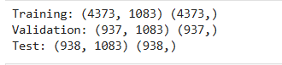
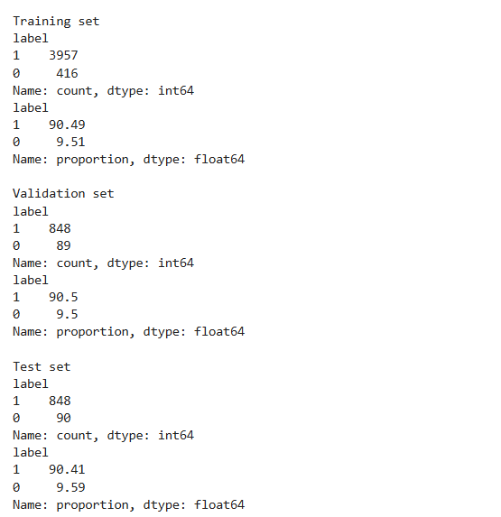

2.5 Leakage Prevention
Several controls were used to reduce leakage.
First, the dataset was split before feature selection. Constant-feature detection was performed on the training set only, preventing information from the validation or test sets from determining which features were kept.
Second, the source column was excluded since the classes were strongly associated with their source datasets: benign examples came from the benign collection, while malware came from VxHeaven and VirusTotal. Allowing the model to see this field would provide an artificial shortcut to the target.
Third, the validation set was used for model development and decision-threshold selection. The 938-record test set remained untouched until the model and 0.10 decision threshold had been selected, after which it was used once for final evaluation.
Figure 5
Code Snippet (Jupyter Lab) Output of Constant Training Features

Note. Found in Jupyter Lab 01_xgboost_training.ipynb
Figure 6
Code Snippet (Jupyter Lab) Output of Removed Training/Validation/Test Features
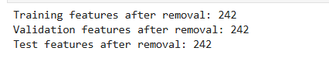
One limitation is that benign and malicious records originate from different source collections. Source-specific artefacts may therefore exist within the retained features even though the explicit source field was removed.
The held-out results should also be interpreted as performance on unseen records from the same source collections, rather than proof of equivalent performance against independently collected contemporary malware.

3. Model Selection and Training

3.1 Model Selection
The structured prediction component uses an XGBoost gradient-boosted decision-tree classifier. This was treated as a Symbolist/tree-based approach, since predictions are produced from an ensemble of decision trees containing learned feature-splitting rules (Chen & Guestrin, 2016).
XGBoost was selected because the malware dataset is structured tabular data containing 242 retained numerical features. Tree-based boosting is suited to this type of problem since it can learn non-linear relationships and interactions between features without needing the input to have a sequential or spatial structure.
For example, characteristics such as entropy, executable size, PE-header values and image/version information may have different significance when considered together. Boosted trees can learn these interactions directly.

3.2 Alternative Approach
A Connectionist neural network was considered as an alternative. Neural networks can learn complex relationships and would have been useful if the project operated on raw bytes, images or sequential executable data.
However, for this project, the inputs were already structured numerical features. A neural network would introduce additional architecture and hyperparameter choices and generally provide less straightforward feature attribution. XGBoost therefore provided a simpler and more appropriate fit for the available tabular dataset.

3.3 Training
The final XGBoost classifier used the following main configuration:
Table 4
XGBoost Classifier Configurations
Trees (n_estimators) | 300
Learning rate | 0.05
Maximum depth | 4
Subsample | 0.8
Column sample | 0.8
Tree method | Hist
Random seed | 42
The model was trained using the 4,373-record training set and the 242 features selected using training data. Validation data was kept separate for model evaluation and subsequent decision-threshold selection.

3.4 Trivial Baseline
A majority-class classifier was used as the trivial baseline. Because approximately 90% of the records were malware, this classifier simply predicted malware for every record.
On the validation set, the baseline achieved:
Table 5
Baseline vs XGBoost Accuracy Values Comparison
Metric | Majority Baseline | XGBoost
Accuracy | 90.50% | 99.47%
Balanced Accuracy | 50.00% | 97.69%
Malware precision | 90.50% | 99.53%
Malware recall | 100.00% | 99.88%
Malware F1 | 95.01% | 99.71%
Although the baseline’s 90.5% accuracy initially looks high, it classified all 89 benign validation samples as malware. Its balanced accuracy was therefore only 50%, showing why raw accuracy can be misleading for this imbalanced dataset.
XGBoost correctly distinguished both classes, producing a validation confusion matrix:
Figure 7
Code Snippet Output of the Baseline and XGBoost Comparison
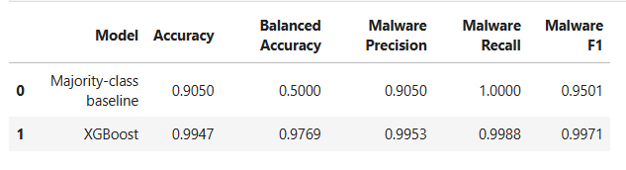
The model therefore outperformed the trivial baseline, especially in balanced accuracy and its ability to recognise benign software. The decision threshold shown I the default 0.50 used for the initial model comparison. The operational threshold was chosen separately using the validation set and the relative cost of false positives and false negatives.

4. Model Evaluation

4.1 Validation Performance
The XGBoost model was first evaluated on the 937-record validation set using the default 0.50 decision threshold. Multiple metrics were used because the dataset is imbalanced.
Table 6
Validation Performance Table for XGBoost
Metric | Validation Result
Accuracy | 99.47%
Balanced Accuracy | 97.69%
Malware Precision | 99.53%
Malware Recall | 99.88%
Malware F1 | 99.71%
ROC-AUC | 99.96%
Note. This uses the default 0.50 decision threshold. The threshold later changed once more tests had been made.
Figure 8
Code Snippet (Jupyter Lab) Output of XGBoost Validation Results
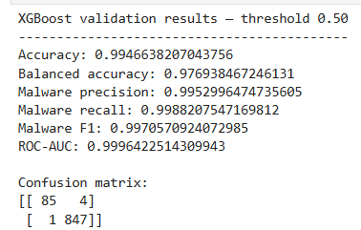
Although performance was high, the default threshold produced one false negative, meaning one malware sample was classified as benign.

4.2 Operational Threshold Selection
For malware triage, the two error types do not have equal consequences. A false positive causes a benign file to be unnecessarily reviewed, while a false negative can allow malware to be treated as benign.
A simple operational cost was defined:
- False positive cost = 1
- False negative cost = 10
The costs are relative instead of monetary values. They represent the decision that missing malware is more serious than requiring additional analyst review. Different thresholds were evaluated using the validation set only.
The lowest operational cost was gained at a threshold of 0.10:
Table 7
Table of Operational Costs at Different Thresholds
Threshold | False Positives | False Negatives | Cost
0.10 | 7 | 0 | 7
0.05 | 8 | 0 | 8
0.35 | 4 | 1 | 14
0.50 | 4 | 1 | 14
0.95 | 2 | 7 | 72
Note. The 0.10 threshold was locked before examining the final test results.
Figure 9
Code Snippet Output of a Detailed Outline of the rate of False Positives and False Negatives
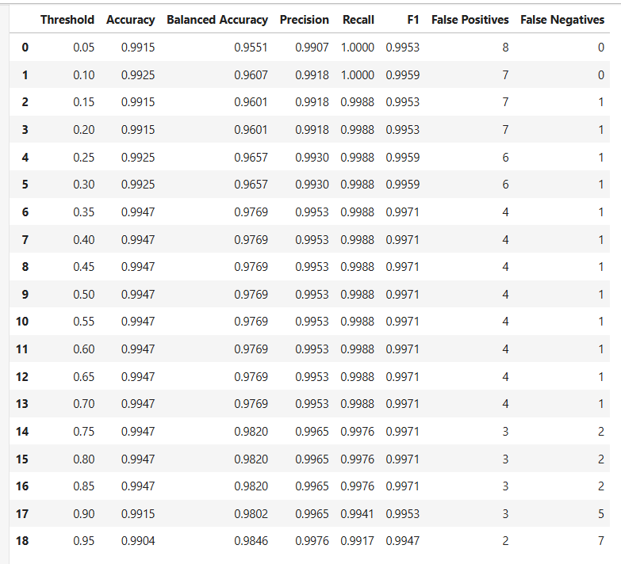
Note. This is a more detailed outline which shows the rate of false positives and false negatives depending on the threshold. As a threshold rate increases, it continues to either be more accurate or less accurate. With this test, we found that the higher the threshold, the less false positives were produced, but more false negatives were generated. A false negative is assigned ten times the cost of a false positive since missing malicious software presents greater security risk than sending a benign file for additional review. This is why threshold 0.10 was then locked in as the final rate as it produces 0 false negatives, and one less false positives than the 0.05 threshold.

4.3 Final Test Results
The locked model and 0.10 threshold were then evaluated once against the untouched 938-record test set.
Table 8
Final Test Results for Evaluation
Metric | Test Result
Accuracy | 99.36%
Balanced Accuracy | 96.67%
Malware Precision | 99.30%
Malware Recall | 100.00%
Malware F1 | 99.65%
Macro F1 | 98.10%
ROC-AUC | 99.99%
Note. All 848 malware records were detected, while six benign records were incorrectly escalated. Under the defined cost model this resulted in an operational cost of 6.
Figure 10
Code Snippet (Jupyter Lab) Output of the Final Test Results using Threshold 0.10
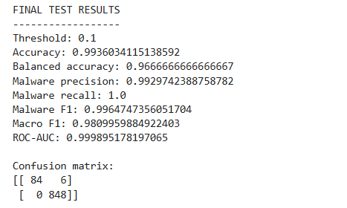
Note. This is a production of the more detailed results, different to Table 8.

4.4 SHAP Analysis
SHAP was used to examine which feature had the best influence on the XGBoost predictions (Lundberg & Lee, 2017). Important featured had included CheckSum, minor_image_version, maximum entropy (ent_max), stack reserve size, DLL characteristics and compile date.
The SHAP summary can also show that a feature does not have a fixed relationship with malware. Different feature values can push individual predictions in different directions.
Figure 11
SHAP Diagram (from Code Snippet Output (Jupyter Lab)) for Further Analysis
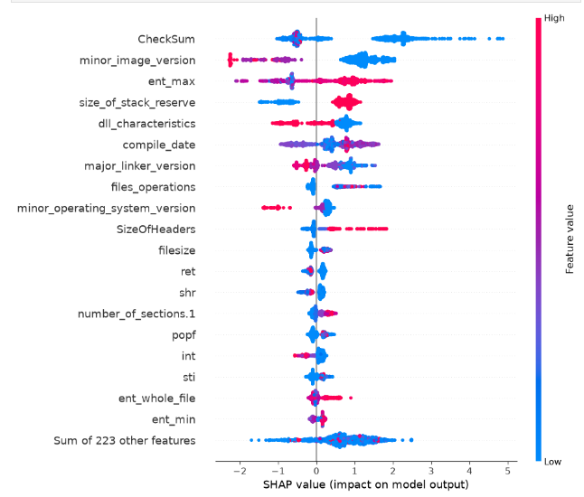
SHAP shows how the trained model used its inputs; it does not prove these features cause malicious behaviour. For example, a high SHAP importance for CheckSum demonstrates that the model relies on that feature, but it does not establish that a particular checksum characteristics can solely cause software to be malicious.
This distinction is important because the benign and malware examples originate from different source collections. Some feature importance could reflect characteristics of the source datasets rather than universally applicable malware behaviour.

4.5 Disparate Performance Audit
Performance was examined across executable-size groups. The group boundaries were derived from the training-set quartiles, instead of being chosen after observing test performance.
Figure 12
Performance Audit based on Different Executable Size Groups
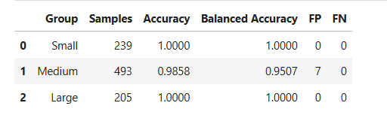
The medium size group showed lower performance and had all seven false positives in this audit, while no false negatives occurred in any size group.
This demonstrates disparate observed error rates but does not prove that executable size had caused those errors. The groups differ in sample size and can contain other related characteristics. The audit therefore identifies an area which requires further investigation rather than establishing a causal bias.
The evaluation supports the models usefulness for this prototype, but the high results should be looked at with caution since the held-out records still originate from the same source collections used during development.

Deployment of the Prediction Service

5.1 HTTP Prediction Service
The trained XGBoost model was deployed on CT200 (inference-llm) as a FastAPI service. This allows OpenClaw and other clients to access the classifier through HTTP without requiring direct access to the model files.
The service runs on:
http://192.168.100.20:8080
Two endpoints were implemented:
Table 9
Endpoints used for SHREDR AI
Method | Endpoint | Purpose
GET | /health | TO check service availability and configuration
POST | /predict | Submit executable features for classification
Note. This table describes the endpoints used for SHREDR AI, including the method, endpoint and purpose.
The health endpoint reports the loaded model configuration, including the expected 242 features and locked 0.10 decision threshold:
Figure 13
Command Prompt Snippet Loading the Status of CT200

5.2 Request Contract
A prediction request is sent as JSON containing a features object. A valid request must contain exactly the 242 features that are expected by the trained model. The service orders the supplied values according to the training feature list before it is passed to XGBoost. This prevents JSON field ordering from changing the model input.

5.3 Response Contract
A successful response lists the classification and supporting model information:
Figure 14
Command Prompt Snippet of Success Response
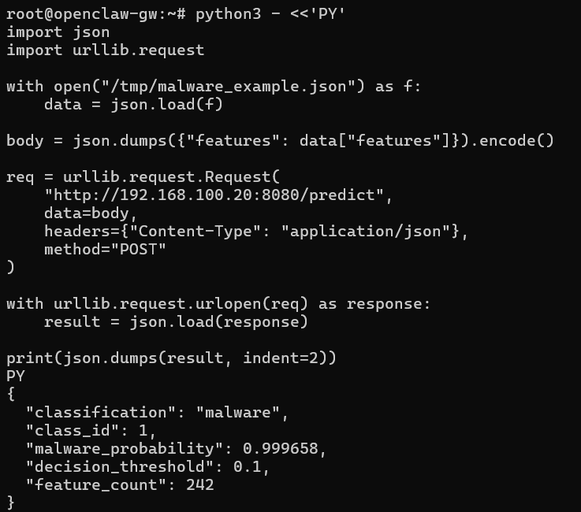
The malware_probability is compared against the 0.10 threshold to produce the final benign or malware classification. Returning the probability and threshold gives downstream components evidence for explaining the decision instead of providing just a class label.

5.4 Malformed Input
This service validating incoming data before prediction. Any requests with missing or unexpected features are rejected instead of ignoring values or silently filling.
This behaviour is necessary because if incomplete feature records were allowed to reach the classifier, it could produce predictions from data which does not match the model’s training schema. A rejected prediction request results in manual review and termination of the automated workflow, instead of the system attempting to generate an incident decision based on invalid data.
For example, a test request containing only a file size feature, it would be rejected:
Figure 15
Command Prompt Snippet of Output showing Error 400 (Deliberate Test)
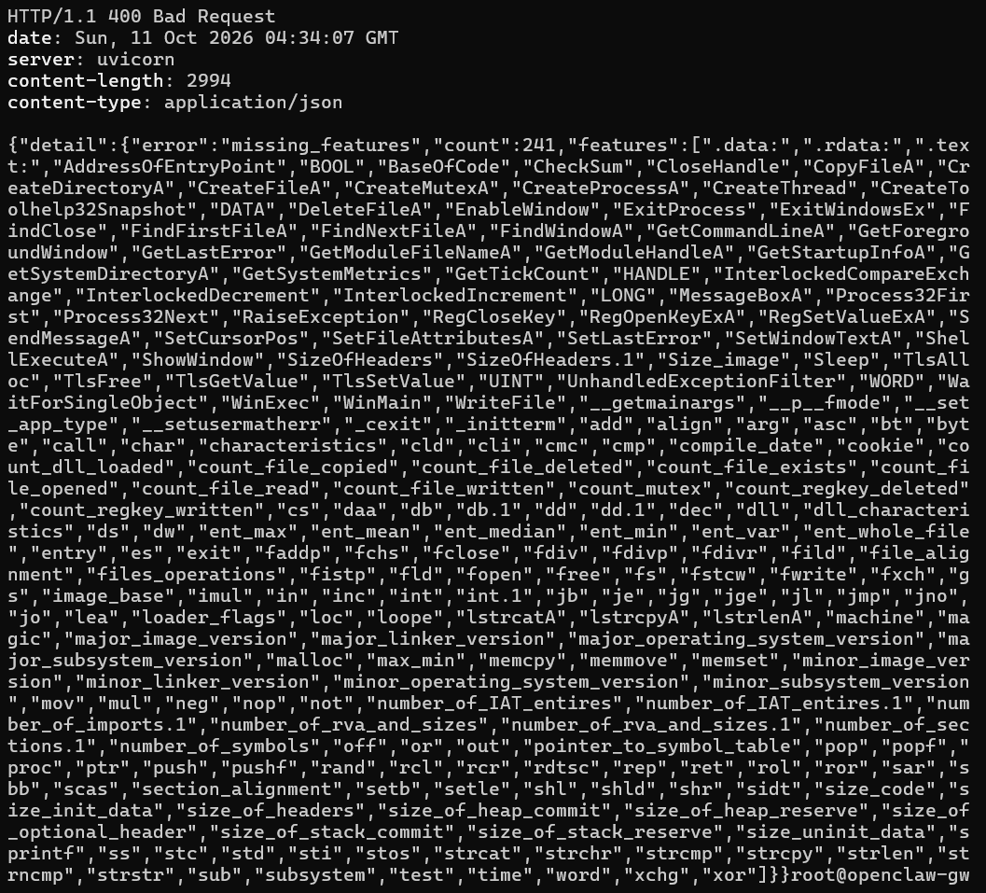
Note. The response identified the error as missing_features, reported that 241 required features are missing and returned the missing feature names.
For a simpler view, this is what would be seen for something sent through that is more specific:
Figure 16
Command Prompt Result showing Deliberate Malformed Input Result for Validation
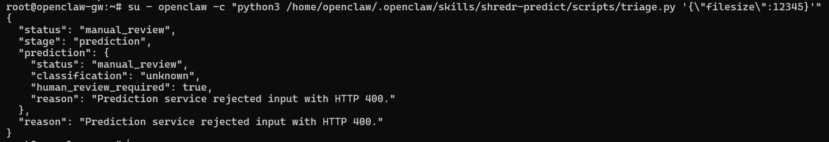

6. Fine-tuning with Unsloth

6.1 Fine-tuning Purpose
The language model in SHREDR AI was fine-tuned to produce consistent malware-triage reports from structured classifier evidence. The language model is not responsible to determine whether a file is malicious. This was decided by the XGBoost classifier. Instead, the model receives the result and supporting information and turns it into a report suitable for an analyst.
The required report format contains three components:
- Risk assessment
- Evidence interpretation
- Recommended action
Fine-tuning was chosen because the improvement was mostly the behaviour and output format of the model. The goal was for the model to consistently follow the reporting structure of SHREDR and to only use the evidence supplied to it.

6.2 Instruction Dataset
A custom instruction dataset was created just for SHREDR AI. The final dataset contained 217 examples. Each example contained an instruction, structured input and expected output. The inputs represent information that could be produced during triage including:
- Classification
- Malware_probability
- Decision_threshold
- File_size_group
- Maximum_entropy
- Digitally_signed
A simplified example of the structure is:
{
'instruction': 'Generate a concise malware triage report from the supplied analysis evidence.', 'input': 'Classification: benign
Malware probability: 0.061
Decision threshold: 0.10
File size group: Large
Maximum entropy: 6.21
Digitally signed: no',

'output': 'Risk assessment: Low
The executable was classified as benign with a malware probability of 6.1%, below the configured 10% decision threshold. The file is not digitally signed, so the benign prediction should not be interpreted as a guarantee of safety.
Recommended action: No malware escalation is required based on this analysis.'
}

The dataset contained both straightforward examples and more difficult situations. These had included confident malware predictions, high-entropy files (classified as benign), digitally signed files classified as malware and predictions close to the 0.10 threshold.
Having these examples were meant to discourage the model from treating one individual characteristic as solid evidence. For example, a digitally signed file should not be considered safe if the classifier probability strongly indicates malware. The system instruction had also told to model to only use the evidence supplied and not invent additional malware indicators.
Figure 17
Instruction Dataset Formatting Example for SHREDR AI’s Internal Components
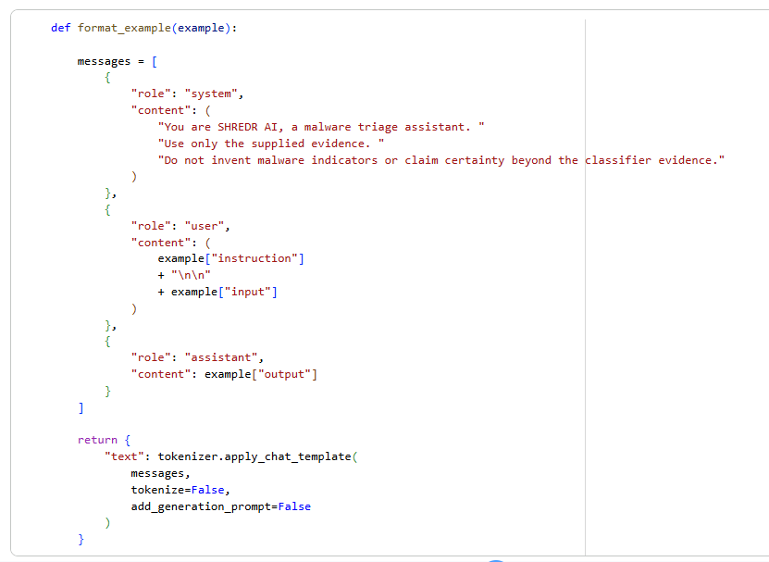

6.3 Dataset Cleaning and Split
Before training, the dataset was checked to ensure each record contained the required instruction, input and output details.
The complete dataset contained 217 valid examples with no duplicate records.
A random seed of 42 was used to divide the dataset:
Table 10
Dataset Division Table
Dataset | Examples | Purpose
Training | 173 | Fine-tuning the model
Validation | 22 | Monitoring training performance
Test | 22
Total | 217
The test examples were separated from the fine-tuning process. They were used to compare the original base model against the fine-tuned model. Keeping a separate test set was important because evaluating the model on examples it had already encountered during training would provide an unrealistic indication of its performance.
Figure 18
Code Snippet (Google Colab) Output of Dataset Split
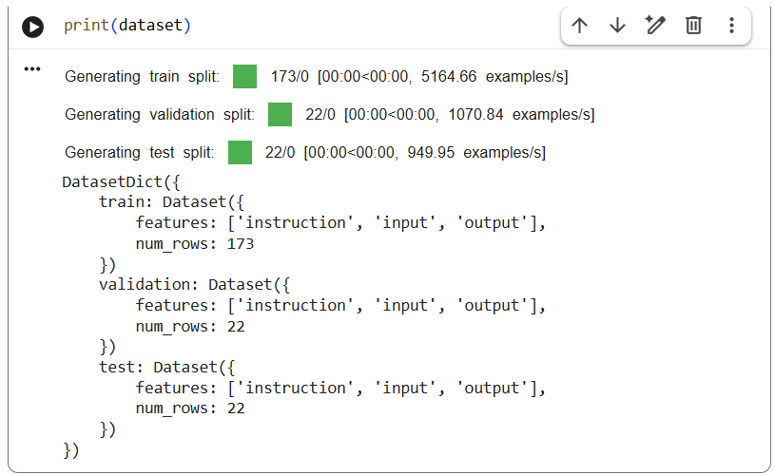

6.4 Dataset Provenance and Licensing
The XGBoost malware classifier was trained using the Malware Static and Dynamic Features VxHeaven and VirusTotal dataset obtained from the UCI Machine Learning Repository (UCI Machine Learning Repository, 2019). This dataset contained 6,248 records across three CSV files, which represent malware samples and benign software.
For language-model fine-tuning, a separate instruction dataset containing 217 synthetic examples was created for SHREDR AI. These examples were made to teach the Qwen model how to interpret classifier results and generate consistent malware-triage reports.
Generative AI assisted with developing the instruction examples, which were checked for structure and consistency (OpenAI, 2026). The instruction dataset did not contain real malware binaries, personal information or confidential organizational records.
The instruction dataset was project-created instead of being downloaded from an external dataset provider. Its provenance and split information were recorded in dataset_manifest.json.
A limitation of using synthetic data, however, is that the examples may be more predictable than real security incident data. Therefore, strong performance on this dataset does not mean the model could perform just as well across every real-world security environment. The structure developed is better use as a demonstrational project.

6.5 Base Model and Unsloth:
The base model selected for SHREDR AI was Qwen2.5-1.5B-Instruct (Qwen Team, 2024). This model was small enough to fine-tune using the available Google Colab environment, while still providing instruction-following and text-generation capabilities which was suitable for the project.
Fine-tuning was implemented using Unsloth and QLoRA on an NVIDIA Tesla T4 GPU (Dettmers et al., 2023; Unsloth, n.d.).
The base model was loaded using 4-bit quantisation, reducing the amount of GPU memory required during training. LoRA adapters were then trained instead of updating every parameter of the original model (Hu et al., 2022).
This approach made it better to fine-tune the model using the available Colab hardware instead of requiring a significantly larger GPU
Figure 19
Google Colab Environment Setup Code and Output
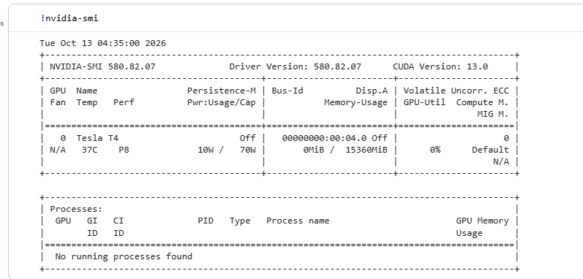
Note. This single code line produces a result that allows us to prep the Google Colab GPU.

6.6 LoRA Configuration
The LoRA adapters were configured with a rank of 16 and alpha of 16.
A LoRA rank of 16 was selected to provide enough adaptation capacity for the model to learn the SHREDR reporting behaviour without making the adapter large. This was appropriate since the training dataset only contained 173 examples. A larger adapter would add additional training capacity despite the small amount of training data.
A physical batch size of two was used due to the available GPU memory. Gradient accumulation was performed over four steps, giving an effective batch size of eight while keeping separate training batches small enough for Colab T4.
Four epochs were used so that the small dataset could be seen multiple times during training while validation loss was monitored for signs of overfitting.
Figure 21
Colab Main LoRA Configuration
Figure 20
Colab Adapters
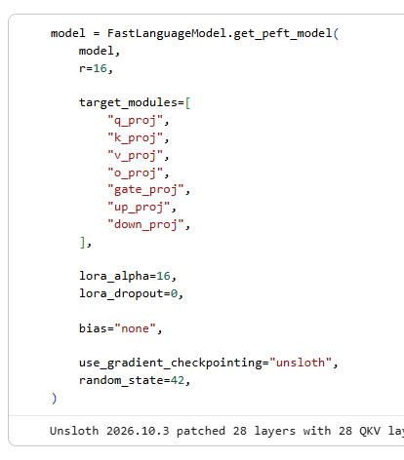
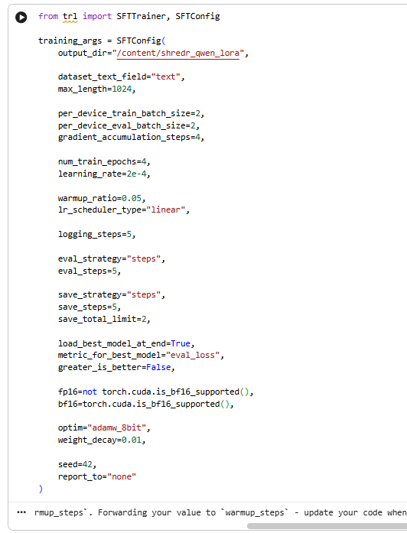

6.7 Training Results and Loss
Training was successful and complete after 4 epochs and 88 training steps. The final recorded aggregate training loss was approximately 0.502.
Validation loss decreased during training and reached approximately 0.099 at step 88.
The loss curves were checked on to determine whether the model was starting to overfit the training examples.
A sign of overfitting would be training loss continuing to improve while validation loss begins increasing. This behaviour was not seen during the four-epoch training run. Validation loss continued to decrease through the final evaluation.
Therefore, there was no seen evidence of validation overfitting during the training run.
The result will still be interpreted cautiously since both the training and validation examples came from the same synthetic dataset-generation process and followed a SHREDR report structure. The validation data may therefore be easier for the model than different real-world malware-triage inputs.
For this reason, the loss curve was not treated as sufficient evidence by itself that the fine-tuned model was successful. A separate test set was retained for the later base-versus-tuned model evaluation.
Figure 23
In-depth Code Snippet (Jupyter Lab) Output for History Loss and Evaluation Loss
Figure 22
Code Snippet (Jupyter Lab) Output for History Loss and Evaluation Loss – Second Test
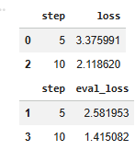
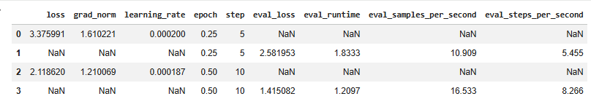
Figure 24
Diagram depicting Fine-Tuning Loss
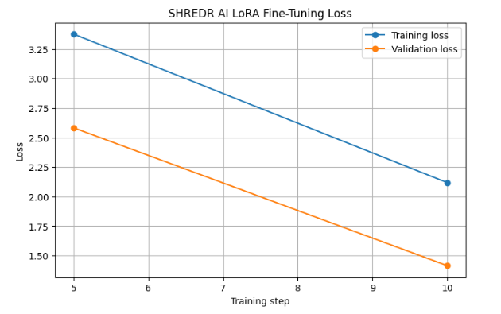
Note.

6.8 Training and Inference Format
The same Qwen chat formatting (Qwen Team, 2024) and SHREDR system instruction were maintained when prepping for the training examples and when testing the model later on.
The system instruction was designed to limit the model to using only the supplied evidence and prevent it from presenting unsupported malware indicators as fact.
After training was complete, the fine-tuned model was then exported for deployment. It was later converted into a quantised GGUF model so that it could run on the CPU-based inference server.
The GGUF fine-tuned model file was called: shredr-qwen2.5-1.5b-tuned-Q4_K_M.gguf.
The effectiveness of the fine-tuning is evaluated separately in the later model-comparison section using the 22 held-out test examples, instead of relying only on the training loss.

7. Export and Deployment

7.1 Exporting the Fine-Tuned Model
After fining-tuned was completed, the SHREDR language model needed to move from the Google Colab training environment to the CPU-only inference environment, which was used by the deployed system.
The fine-tuned Qwen2.5-1.5B-Instruct model was exported to the GGUF (GPT-Generated Unified Format) format. GGUF is supported by llama.cpp, which was already available on the EduStack inference contained and let the model run locally without needing a GPU (ggml-org, n.d.).
Two GGUF models were kept:
Figure 25
Command Prompt Output defining GGUF Files – Based and Tuned Versions
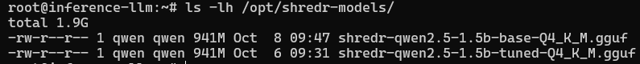
The tuned GGUF file was approximately 986MB, allowing the model to fit within the available container resource.
Both models were then transferred to the CT200 inference server and was stored under /opt/shredr-models.

7.2 Quantisation Selection
Both models were exported using Q4_K_M quantisation.
The target inference environment was an 8GB CPU-only container, so deployment size and memory requirements were important considerations. Running the model at a high precision would require more memory and provide limited benefit for the small reporting task SHREDR utilizes.
Q4_K_M reduces model weights to 4-bit quantisation (ggml-org, n.d.) while retaining precision where it is appropriate. This reduces the deployed model size compared with an unquantized model.
For SHREDR, Q4_K_M provided a compromise between model quality, memory consumption, inference speed and deployment size.
The resulting tuned model was approximately 986MB on disk and could run within the available CT200 resources without a GPU.
The purpose of the language model was also constrained. It receives a small amount of verified classifier evidence, and it generates a small report. It is not used for long-context reasoning or final malware classification itself. This made the smaller quantised deployment appropriate for the projects application.

7.3 Chat Template Consistency
The formatting used when communicating with the model during inference was kept consistent with the formatting used during fine-tuning.
During training, the Qwen chat template was used to convert the system instruction, user input and expected assistant response into the format which is expected by Qwen2.5 (Qwen Team, 2024).
The conversation is as follows:
System -> “You are SHREDR AI, a malware triage assistant…” -> User -> Classifier evidence -> Assistant -> Risk assessment and Evidence interpretation.
The deployed model continued to use the Qwen-compatible chat format instead of introducing a different prompt template after training.
This was necessary because the fine-tuning examples taught the model its SHREDR behaviour within this structure. Changing the template now during deployment can change how the model interpreted system, user and assistant messages and make the deployed behaviour inconsistent with the model that was evaluated during fine-tuning.
The deployed model was tested using the same SHREDR-style classifier evidence and produced the expected report structure successfully.

Figure 26
Code Snippet (Google Colab) Output of Chat Template Example Result
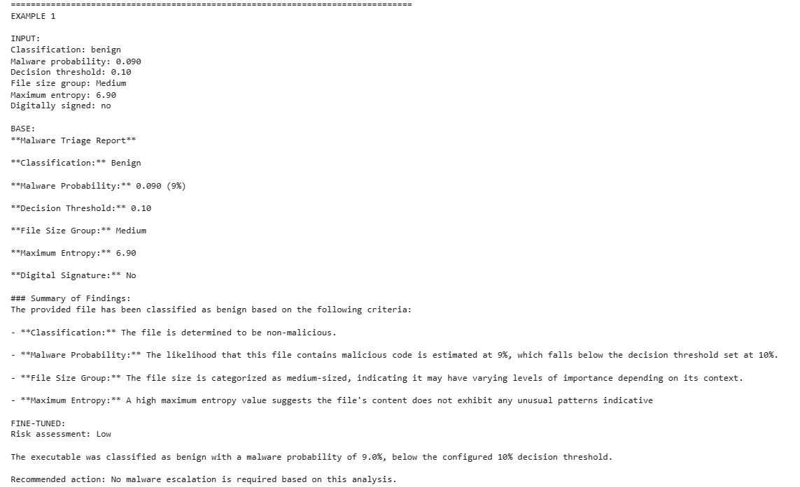

7.4 Deployment to CT200
The GGUF models were deployed to the CT200 inference-llm container.
The fine-tuned model was served using the existing llama.cpp infrastructure (ggml-org, n.d.):
- Model Alias: shredr-tuned
- Port: 8010
- Context: 8192
- Parallel: 1
- Threads: 4
- Temperature: 0
The tuned service used /opt/shredr-models/shredr-qwen2.5-1.5b-tuned-Q4_K_M.gguf
The model was configured as a system service so that it could be managed independently of the OpenClaw workflow.
Its deployment could be verified with ‘systemctl status shredr-tuned --no-pager’:
Figure 27
Command Prompt Output of Deployment Verification for CT200
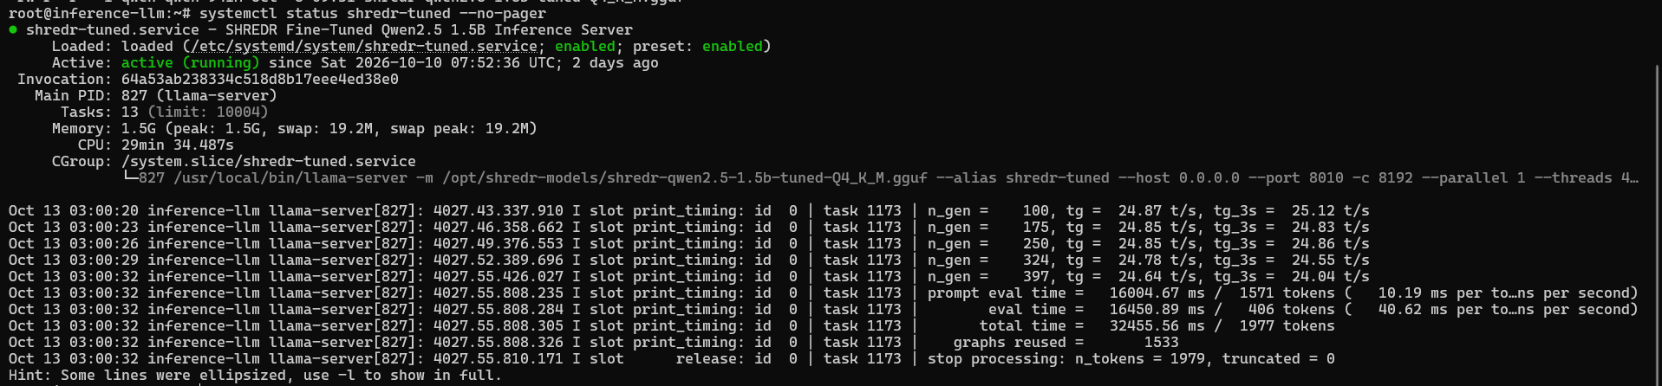
The service was confirmed as active and responded to inference requests.

7.5 Registering the Router Backends
Both the fine-tuned model and original base model were registered as inference backends.
The router configuration contained:
Figure 28
Command Prompt Response for Router Configuration
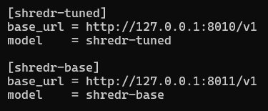
The fine-tuned model was therefore available on port 8010, while the base model was configured on port 8011.
The existing EduStack MultiShim service on port 8001 provided a common routing layer through which the configured models could be addressed.
This arrangement was particularly useful for evaluation because the original and fine-tuned models could be given equivalent prompts while remaining separate inference backends.
Figure 29
Command Prompt Output For Edustack Configuration Results
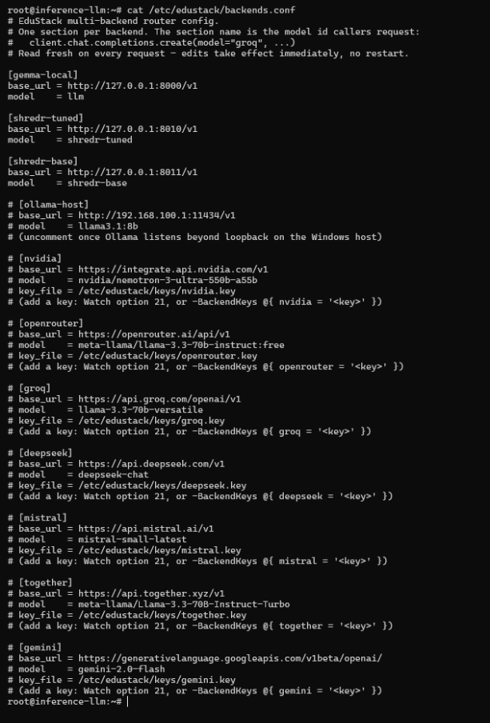

7.6 Base Model Verification
The original Qwen base model was also exported as a Q4_K_M GGUF and successfully deployed as the shredr-base backend.
It was tested to verify that it could respond through the deployed inference environment. Once this verification and the base-versus-tuned testing was complete, the base model service was stopped and disabled to conserve memory on the constrained CT200 container.
The base more did not need to remain continuously active during normal SHREDR operation. Its purpose was now to provide a deployment-equivalent baseline against which the fine-tuned model could be evaluated.
The tuned model remained the model used by the SHREDR workflow.

7.7 Final Deployment Architecture:
After deployment, the language-model portion of SHREDR operates as follows:
CT201 -> inference request -> CT200 -> shredr-tuned llama.cpp :8010 -> Q4_K_M tuned GGUF
= Structed SHREDR report
The base model was separately registered as:
shredr-base -> llama.cpp :8011
This allowed the project to retain both the original and fine-tuned models in the same deployment environment while using the fine-tuned model for the operational workflow.

7.8 Deployment Outcome
The export and deployment process demonstrated that the model fine-tuned in the GPU-based Colab environment could be converted into a compact GGUF artefact and subsequently run on the CPU-only EduStack infrastructure.
The final configuration provided:
Table 11
Deployment Configuration for SHREDR AI
Requirement | Implementation
GGUF export | Qwen2.5-1.5B exported to GGUF
CPU deployment | Llama.cpp on CT200
Quantisation | Q4_K_M
Tuned model | shredr-tuned, port 8010
Base model | shredr-base, port 8011
Router | MultiShim, port 8001
Training/Inference formatting | Qwen chat template retained
Base and tuned registration | Both configured as router backends

This provided the deployment foundation required for the base-versus-tuned evaluation and for integration of the tuned model into the complete OpenClaw SHREDR workflow.

8. Agent Orchestration

8.1 OpenClaw’s Role in SHREDR AI
OpenClaw was deployed on CT201 (openclaw-gw) to provide the orchestration layer between the prediction service, fine-tuned language and Gitea.
The purpose of this layer was to take a malware feature record and coordinate the full triage process. OpenClaw itself does not perform the malware classification. Instead, it uses XGBoost prediction service hosted on CT200 and it determines whether the workflow should continue with its process.
The process is:
Structured feature record -> CT201 – OpenClaw/SHREDR Skill -> CT200 – XGBoost prediction API -> Guardrail check.
From the guardrail check, it then progresses depending on the response. If it is invalid, a manual review is made, and it stops. Otherwise, it continues on to the fine-tuned Qwen and a report is made. Finally, it gets to CT202 – Gitea and stops.
This separation ensures the language model does not determine the classification and that deterministic checks can stop the workflow before an external action is performed.

8.2 OpenClaw Skill
A dedicated OpenClaw skill named shredr-predict was created on CT201.
The skill is stored at:
/home/openclaw/.openclaw/skills/shredr-predict/
Its main components include SKILL.md and two files in ‘/scripts/’, predict.py and triage.py. SKILL.md defines the purpose and operating rules for the SHREDR workflow. Predict.py handles communication with eh XGBoost prediction endpoint and validates the prediction response. Triage.py coordinates the complete process, including prediction, guardrail evaluation, language-model reporting and Gitea issue creation.
The completed skill was validated by OpenClaw and reported as follows:
Figure 30
Command Prompt Output of OpenClaw Skill Validation
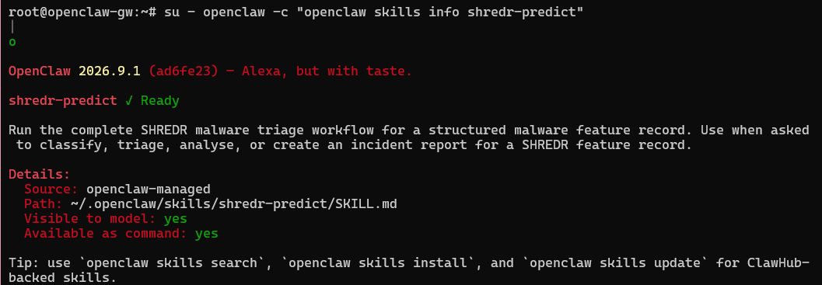

8.3 Goal and Stopping Condition
The goal of the OpenClaw workflow was defined as:
‘Process one complete structured malware feature record, gain a verified prediction, generate a SHREDR triage report when permitted by the guardrails and create an auditable incident issue in Gitea.’
An explicit stopping condition was defined so that the workflow could not possibly continue performing actions after completing its task.
A successful workflow stops when:
‘One verified Gitea incident issue has been created.’
A second stopping path exists when the workflow cannot safely continue:
‘If prediction validation or a guardrail requires manual review, report the reason and stop without creating a Gitea issue.’
This gives the workflow two clear outcomes:
Table 12
SHREDR AI Workflow Outcome Options
Outcome | Action | Stopping Condition
completed | One Gitea incident created | Stop after verified issue creation
manual_review | No incident created | Stop and require human review

This prevents repeated issue creation and prevents the system to attempt bypassing a failed prediction or safety check.

8.4 Prediction Endpoint as a Tool
The prediction component communicates with the XGBoost HTTP service deployed on CT200:
http://192.168.100.20:8080/predict
The tool accepts the structured malware feature record and posts it to the prediction service. A successful response provides information including its classification, malware probability and its decision threshold. The prediction result is then used by the workflow to determine what happens next.
Importantly, the language model is not permitted to replace a failed prediction with its own judgement. If the prediction API rejects the input, becomes unavailable or returns invalid responses, the workflow moves to manual_review and stops.
For example, submitting only {“filesize”: 12345} caused the prediction stage to reject the record because the remaining required features were absent. The workflow stopped instead of the language model attempting to estimate any missing information. (As mentioned in 5.4, with the reference of Figure 15)
This provides a set contract between the prediction model and the orchestration layer.

8.5 Using the Prediction to Decide
After a successful prediction, deterministic checks are performed before the workflow is allowed to continue.
One important check concerns predictions close to the selected 0.10 decision threshold. If the test results are close to the cutoff line, the system cannot make a definitive decision automatically and would require human review
For example:
Table 13
Probability and Threshold Deterministic Results
Probability | Distance from 0.10 | Result
0.079 | 0.021 | Continue
0.081 | 0.019 | Human Review
0.099 | 0.001 | Human Review
0.101 | 0.001 | Human Review
0.119 | 0.019 | Human Review
0.121 | 0.021 | Continue
This decision is made by deterministic program logic instead of asking the model whether it feels confident or not.
If the result passes these checks, the classifier evidence can be sent to the fine-tuned Qwen model to generate the report. This design is necessary since the fine-tuned model had demonstrated one error on a held-out example immediately below the decision threshold. The boundary check therefore gives an additional safety layer around an observed model weakness.

8.6 Language-Model Report Generation
For predictions permitted to continue, triage.py sends the classifier evidence to the fine-tuned SHREDR Qwen model hosted on CT200.
The model only gets the relevant evidence and is told to produce the required structure:
- Risk Assessment
- Evidence Interpretation
- Recommended Action
For the successful malware test, XGBoost returned approximately:
- Classification: Malware
- Malware Probability: 0.999658
- Decision Threshold: 0.10
- Human Review: False
The tuned model then produced a high-risk assessment and recommended that the suspicious executable should not be run and should be escalated for review.
The generated language does not replace the original classifier evidence. Both can be retained in the final incident so that an analyst can distinguish the model’s explanation from the prediction that it was based on.

8.7 Acting on a Real Gitea Artefact
After successful prediction, guardrail checking and report generation, the workflow then performs an external action against the Gitea server hosted on CT202.
The target repository is:
beetle/shredr-incidents
The workflow uses the Gitea API to create one incident issue containing the SHREDR report and verified classifier evidence.
The successful full-system test had generated a new issue containing the risk assessment, evidence interpretation, recommended action and prediction details.
The Gitea credentials used by the workflow was stored separately from the skill code, and the token was configured with restricted repository permissions instead of unrestricted admin access.

8.8 Independent Verification
The success of the external action was not accepted on its own just because the workflow reported that it succeeded.
After the successful triage run, the shredr-incidents repository was opened separately through the Gitea interface. The newly created issue was shown, and its contents could be looked at directly.
This independently confirmed that:
OpenClaw workflow reported success + Gitea contained the new issue = External action verified
This distinction is important because an orchestration process or LLM claiming that an action occurred is not by itself proper evidence that the external system was changed.
Figure 31
Command Prompt Output for Independent Verification for OpenClaw
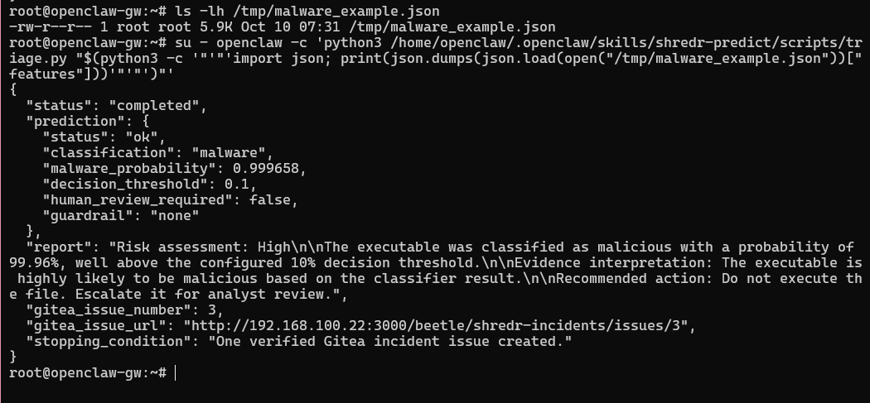

8.9 Restricted OpenClaw Configuration
The OpenClaw configuration was restricted so that the SHREDR agent could also only have access to the functionality required for this task.
The main agent was configured to use the ‘shredr-predict’ skill with its available tool access restricted to ‘exec’.
This reduced any unnecessary capability and reduced the context number being given to the small 1.5-billion-parameter language model.
This restriction follows a least-privilege approach: the workflow should have only the capabilities required to perform the intended SHREDR operation.
Figure 32
Command Prompt Output for Restricted OpenClaw Configuration
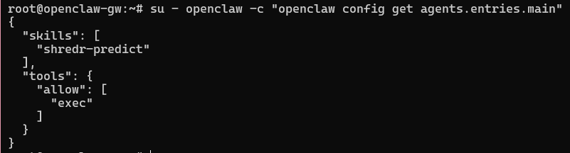

8.10 Limitations of Autonomous Tool Selection
During development, an attempt was made to let the fine-tuned 1.5B model to select and use the OpenClaw execution tool autonomously. Although the model generated a valid textual response, it did not reliably use the required tool.
For this reason, the SHREDR implementation does not claim the language model autonomously chooses every action in the workflow.
What is done instead of OpenClaw provides the agentic environment and SHREDR skill, while the safety-critical orchestration is done deterministically through triage.py. The language model is used where language generation is appropriate, while prediction, validation, stopping conditions and external action sequencing remain controlled by program logic.
This was considered much safer than depending on a language model to select tools and enforce the stopping condition, which needs high reliability.

8.11 Orchestration Outcome
The final implementation successfully connected the three major SHREDR components:
Table 14
Components in SHREDR AI and their Responsibilities
Component | Responsibility
XGBoost API | Malware prediction
OpenClaw/SHREDR skill | Workflow orchestration and decision controls
Fine-tuned Qwen | Analyst-readable report generation
Gitea | External incident artefact and audit trail
For a valid high-confidence malware record, the workflow obtained the prediction, passed the deterministic checks, generated the report, created one Gitea incident and stopped.
For any invalid or uncertain input, the workflow returns a manual-review result and stops without continuing to report generation or Gitea issue creation.
This shows the intended orchestration while keeping the external action bounded and independently verifiable.

9. Guardrails and Failure Handling

9.1 Purpose of the Guardrails
SHREDR AI was designed so that a failure in one component does not result in language model attempting to continue the workflow. This is important because the system combined a machine-learning classifier, a language model and an external action in Gitea.
Deterministic checks were then implemented in the SHREDR workflow before report generation or external action were permitted.
The failure behaviour is:
Input -> prediction service -> validation/guardrails.
If safe, then Qwen -> Gitea -> STOP. Otherwise, if failure/uncertain -> manual review -> stop
The language model is not permitted to override these controls.

9.2 Failure Mode 1 – Invalid or Incomplete Prediction Input
The XGBoost prediction model requires the same 242 features that were retained during model training.
A specific prediction-service control was implemented to prevent incomplete records from being classified. The API checks the supplied feature names against the saved feature list before performing inference.
For example, the following deliberately invalid input was tested: {“filesize”: 12345}. Only one feature was provided when 242 were required. The prediction API rejected the request with an HTTP 400 response identifying that 241 features were missing.
When this was passed through the SHREDR triage workflow, the result was:
“status: manual_review
stage: prediction”
The workflow stopped at the prediction stage. The fine-tuned language model was not used to estimate the missing values, and no Gitea issue was created.
This was important because allowing missing features to be invented or replaced could result in a malware prediction being based on data that did not describe the analysed file.
Figure 33
Command Prompt Output for Failure Mode 1 – Invalid/Incomplete Prediction Input
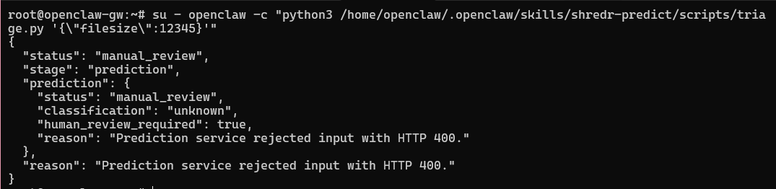

9.3 Failure Mode 2 – Prediction Service Unavailable
he complete workflow depends on the XGBoost service on CT200 being available. A service outage was therefore treated as a safety failure rather than an opportunity for the language model to make its own malware judgement.
This was tested by temporarily stopping the prediction service and submitting an otherwise valid feature record.
The workflow detected the endpoint could not be reached and returned a manual-review result.
The required behaviour is:
Prediction API unavailable -> Do NOT ask Qwen to classify the file -> manual_review -> STOP
The prediction service was restarted after the failure test.
This ensures the model could not possibly silently become a substitute malware classifier when the actual XGBoost classifier is unavailable.

9.4 Failure Mode 3 – Prediction Close to the Decision Threshold
A successful API response does not mean that SHREDR should continue.
The XGBoost operational decision threshold was set to 0.10. An additional uncertainty region of +/-0.02 was implemented around this threshold. Therefore, predictions close to the threshold require human review before the workflow can proceed.
The boundary behaviour was tested with several values, as mentioned in Table 13. The guardrail therefore behaves on both sides of the threshold rather than only reviewing low-confidence malware predictions.
This control was informed by the later language model evaluation. The fine-tuned model’s one incorrect held-out assessment happened at the malware probability of 0.090, immediately below the 0.10 threshold. The deterministic guardrail would capture a result at this probability and require human review rather than relying on the language model’s risk interpretation.
Figure 34
Command Prompt Output for Failure Mode 3 – Prediction Close to Decision Threshold
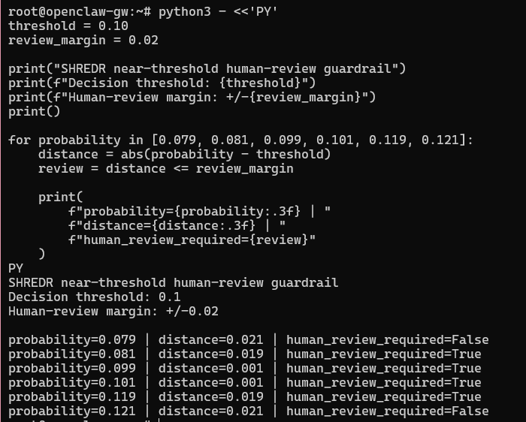

9.5 Additional Input Validation
The prediction tool can also check whether supplied feature values are necessary for the numerical XGBoost model.
For example, a value like {“filesize”: “this is not a number”}, must not be converted into a prediction. Non-numeric, invalid or non-finite values causes the request to fail and must move to manual review.

9.6 Human Approved Boundary
SHREDR AI is a triage and reporting system rather than an autonomous malware-remediation system. An explicit rule was then applied to actions that could affect an executable, device or production environment:
“SHREDR AI must never execute, delete, modify, upload, move, quarantine or otherwise act on a suspected malware file, or perform remediation against an endpoint, without human approval”
This is a necessary rule because the current workflow exposes no tool or code path capable of performing these operations. The automated external action is limited to creating an incident record in the dedicated Gitea repository.

9.7 Guardrail Outcome
The implemented controls demonstrate multiple types of failure handling rather than relying on a single error handler.
The most important cases were:
- Prediction-service failure: incomplete input is rejected
- Infrastructure failure: an unavailable prediction service results in manual review rather than LLM-based classification.
- Model uncertainty: predictions within +/-0.02 of the operational threshold require human review
- Malformed data: invalid numerical values cannot silently proceed to inference
In addition, the system has an explicit human-approval boundary preventing SHREDR from performing destructive or operational actions autonomously against suspicious files or endpoints.

10. System Evaluation

10.1 Base Model vs Fine-Tuned Model
The original Qwen2.5-1.5B-Instruct model and the fine-tuned SHREDR model were compared using the same 22 held-out test examples. The input prompts and evaluation method were kept the same so that the model was the main variable being compared.
Both models also registered as separate router backends, allowing the base and tuned versions to be tested in the same deployment environment.
Table 15
Base Model vs Fine Tuned Model Evaluation Criterion Comparison Table
Evaluation criterion | Base model | Fine-tuned model
Correct risk assessment | 0% | 95.45%
Required report headings | 0% | 100%
Malware probability mentioned | 22.73% | 100%
Decision threshold mentioned | 100% | 100%

The fine tuned model correctly produced the expected risk assessment for 21 of 22 test examples and followed the required SHREDR report structure. The base model was not as consistent and produced only general responses which did not follow the reporting format.
These results prove that fine-tuning had improved the model’s ability to follow the specific SHREDR reporting behaviour.
Figure 35
Code Snippet Output of Base and Fine-Tuned Model Evaluation on the 22 held-out test examples
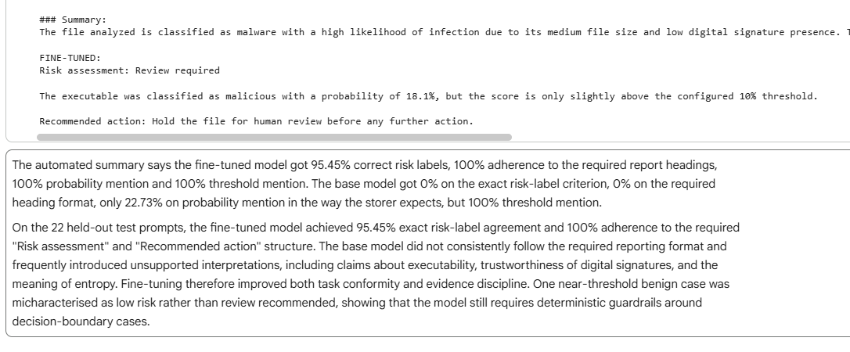
10.2 Fine-tuned Model Failure
The fine-tuned model was not perfect. One held-out example had a malware probability of 0.090, which is below the threshold of 0.10. The expected behaviour was to recommend review because the prediction was close to the threshold. Instead, the fine-tuned model produced a Low risk assessment without escalation.
This failure attributed to the language-model component, rather than XGBoost, because the classifier probability and threshold supplied to the model were correct.
The deterministic +/-0.02 human-review guardrail implemented in the system prevents this language-model error from progressing automatically
Figure 36
Code-snippet Output of Boundary Case Failure Identified during Fine-tuned Model Evaluation
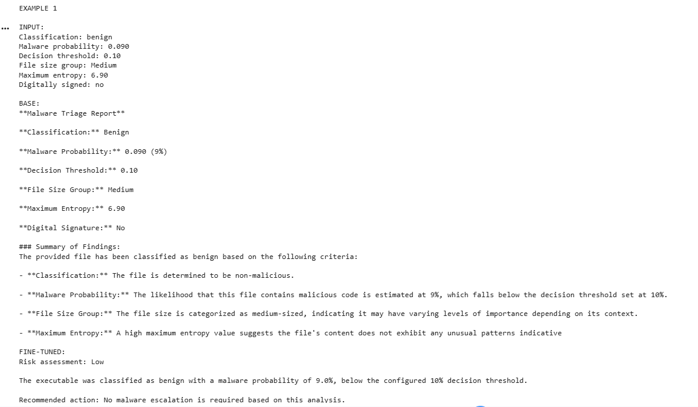

10.3 Complete System Evaluation
The complete SHREDR workflow was tested against criteria defined for successful and failed operation.
The main criteria were:
- Valid high-confidence input should produce a prediction, structured report and one Gitea incident;
- Invalid or unavailable prediction results should stop safely;
- Uncertain predictions should require human review;
- The workflow should not perform destructive actions

These results were observed:
Table 16
Final Results Table of Each Test, Expected Behaviour, Component and their Pass/Fail Verdict
Test | Expected Behaviour | Result | Component
High-confidence malware | Report and one Gitea issue | Pass | Complete System
Missing features | Manual review and stop | Pass | Prediction/API validation
Prediction API unavailable | Manual review and stop | Pass | Prediction service
Near 0.10 threshold | Human review and stop | Pass | Guardrail
Non-numeric input | Manual review and stop | Pass | Input validation
Autonomous tool selection | Tool should be invoked | Fail | Language model/Agent layer
The full-system test classified the supplied record as malware with a probability of approximately 0.999658, generated the required SHREDR report and created one independently verified Gitea incident.
Figure 37
SHREDR AI Incident Report in Gitea
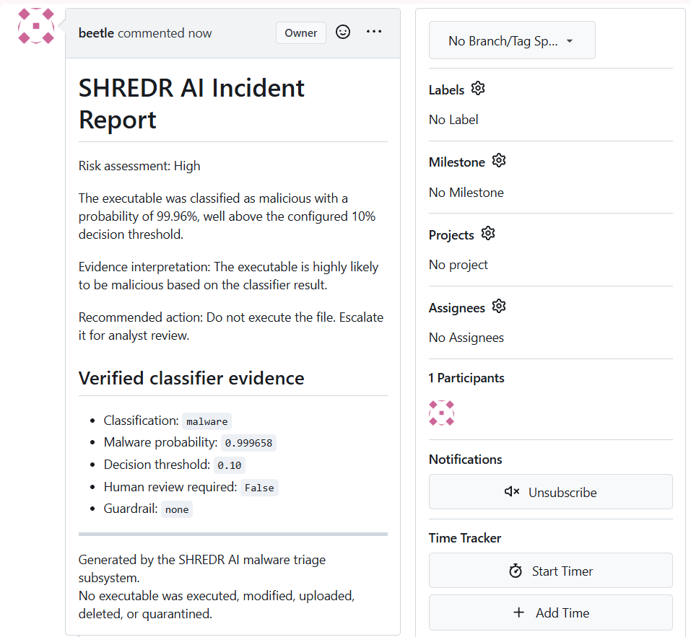

10.4 Failure Attribution
The main system failure can be attributed to specific components instead of treating SHREDR as a single model.
The boundary-case reporting error started from the fine-tuned language model, while the unsuccessful autonomous tool-selection test originated from the agent/model interaction layer. Prediction-service outages were correctly detected by the orchestration layer rather than being mistaken for classifier results.
Since autonomous tool selection was not exactly reliable, the system used deterministic triage.py orchestration for the workflow instead of depending on the model to choose tools correctly.
Overall, the system successfully handled the tested prediction, reporting, guardrail and Gitea workflows.

11. Critical Analysis and Report

11.1 Business Implications
SHREDR AI shows how machine learning and language models could assist with repetitive malware triage. The XGBoost model provides a consistent initial classification, while the fine-tuned language model turns the result into a human-readable report for an analyst.
The main business benefit would be reducing the time required to perform initial triage and document incidents. Integration with an issue-management system such as Gitea also provides an auditable record of the result.
However, automation also creates costs and risks. False positives can create unnecessary analyst workload, while a false negative can allow malicious software to be treated as benign. For this reason, SHREDR wouldn’t replace security staff, it would just remain a decision-support system.

11.2 Technical Implications
The prototype can combine several independent components: an XGBoost classifier, HTTP prediction service, fine-tuned Qwen model, OpenClaw orchestration and Gitea.
A significant technical limitation is the training data. The benign and malware samples originated from different source collections. This does pose a risk that the classifier has learned characteristics associated with the dataset resources instead of the characteristics that generalise to new malware. Although performance on the held-out test data was high, this cannot prove equivalent performance on real-world malware classification.
The language model also demonstrated limitations. It had handled one held-out example incorrectly as it was close to the classification threshold and autonomous OpenClaw tool selection was not reliable. Deterministic orchestration and guardrails were used for safety-critical decisions.

11.3 Social Implications
AI-assisted security systems can create a risk of automation bias, where users place high trust in an automated result because it is technically detailed or appears confident.
SHREDR attempts to reduce this risk by keeping the classifier probability and decision threshold alongside the generated explanation. Predicts close to the threshold are directed to human review.
The generated report should be considered as supporting information than a final definitive verdict whether a file is safe or malicious.

11.4 Accountability
Responsibility for actions taken from SHREDR’s output remains with the organisation and authorized human operator, not the language or machine-learning model.
This is very important if an incorrect classification leads to a malicious software being allowed to continue or a legitimate file being blocked.
The current prototype does not allow autonomous destructive actions. SHREDR cannot execute, delete, modify, upload, quarantine or act on suspicious files or remediate endpoints without human approval.
Gitea can also provide an audit trail so that predictions, reports and resulting incidents can be reviewed instead of relying on the model’s description on what happened.

11.5 Requirements before Production Use
SHREDR is a prototype and would require further development before production deployment.
The most important changes would be:
- Investigation and reduction of dataset-source bias
- Secure authentication and encrypted communication between services
- A formal human approval workflow for security actions
- Logging of model and software versions for audits
- Validation against a larger, independent and more recent malware dataset
- Improved credential management
A production implementation would also need a secure feature-extraction stage. The current prototype accepts pre-extracted structured features and does not analyse or execute uploaded executable files.

11.6 Submission Documentation
The final SHREDR AI submission includes the project repository and supporting evidence, including:
- XGBoost data preparation, training and evaluation notebook
- LLM instruction dataset and fine-tuning notebook
- Trained model configuration and feature definitions
- Exported GGUF model
- FastAPI prediction service
- OpenClaw SHREDR skill and orchestration scripts
- Configuration required for model deployment
- Evaluation results
- Guardrail and failure testing evidence
- This report documenting the design, implementation, evaluation and limitations

11.7 Conclusion
SHREDR AI demonstrates a complete AI-assistant malware triage workflow which combines conventional machine learning with a fine-tuned language model and agentic orchestration.
The prototype was able to achieve strong held-out XGBoost performance and fine-tuning substantially improved the language model’s ability to create the necessary report format. However, by testing the system, it has identified limitations in dataset generalisation, autonomous tool selection and boundary-case language-model behaviour.
For these reasons, the system should be treated as an analyst decision support instead of a final malware remediation. Further independent validation, security controls, monitoring and human oversight should be required before SHREDR is deemed suitable for production use.

Generative AI Use Statement
OpenAI ChatGPT was used during the development of this assessment to assist with brainstorming, troubleshooting, explanation of technical concepts, review of code and generation and review of synthetic instruction examples (OpenAI, 2026). All implementation decision, testing and evaluation were reviewed by the author.

References
Chen, T., & Guestrin, C. (2016). XGBoost: A scalable tree boosting system. Proceedings of the 22nd ACM SIGKDD International Conference on Knowledge Discovery and Data Mining. https://dl.acm.org/doi/10.1145/2939672.2939785

Dettmers, T., Pagnoni, A., Holtzman, A., & Zettlemoyer, L. (2023). QLoRA: Efficient finetuning of quantized LLMs. Advances in Neural Information Processing Systems, 36. https://arxiv.org/abs/2305.14314
ggml-org. (n.d.). llama.cpp [Computer software]. GitHub. https://github.com/ggml-org/llama.cpp
Hu, E. J., Shen, Y., Wallis, P., Allen-Zhu, Z., Li, Y., Wang, S., Wang, L., & Chen, W. (2022). LoRA: Low-rank adaptation of large language models. International Conference on Learning Representations. https://arxiv.org/abs/2106.09685
Lundberg, S. M., & Lee, S.-I. (2017). A unified approach to interpreting model predictions. https://arxiv.org/abs/1705.07874
OpenAI. (2026). ChatGPT [Large language model]. https://chatgpt.com/
Qwen Team. (2024). Qwen2.5-1.5B-Instruct [Large language model]. Hugging Face. https://huggingface.co/Qwen/Qwen2.5-1.5B-Instruct
UCI Machine Learning Repository. (2019). Malware static and dynamic features VxHeaven and Virus Total [Data set]. https://archive.ics.uci.edu/dataset/541/malware+static+and+dynamic+features+vxheaven+and+virus+total
Unsloth. (n.d.). Unsloth documentation. https://unsloth.ai/docs

